4. Web Services
Apache HTTP Server
Install
sudo dnf install httpd -y
sudo systemctl start httpd
sudo systemctl enable httpd
systemctl status httpd
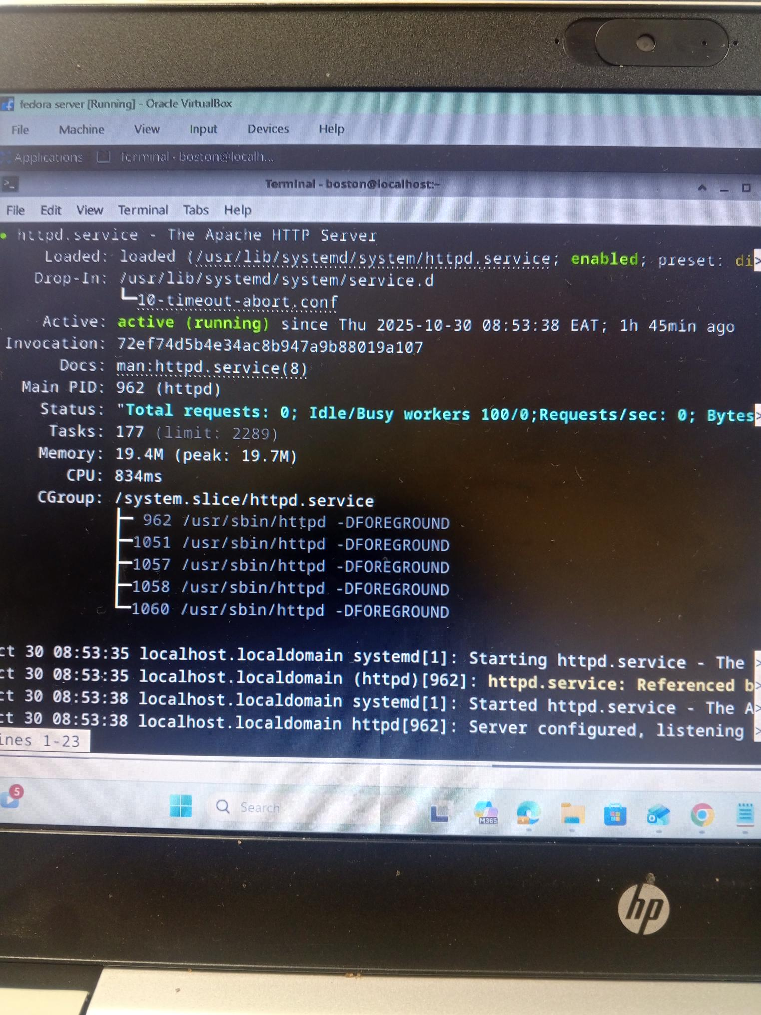
Open your fedora browser
Test 10.0.2.15 for me this is my server ip


SSL / HTTPS
sudo dnf install mod_ssl -y
sudo openssl req -newkey rsa:2048 -nodes -keyout /etc/pki/tls/private/server.key -x509 -days 365 -out /etc/pki/tls/certs/server.crt
Enable SSL
sudo systemctl restart httpd
sudo nano /etc/httpd/conf.d/ssl.conf

Security
sudo systemctl status firewalld
allow http
sudo firewall-cmd --permanent --add-service=http
sudo firewall-cmd --permanent --add-service=https
sudo firewall-cmd –reload
Allow custom port (e.g. 8080):
sudo firewall-cmd --permanent --add-port=8080/tcp
sudo firewall-cmd –reload
View rules
sudo firewall-cmd --list-all

OpenVPN
sudo dnf install openvpn -y
start
sudo systemctl start openvpn-server@server
sudo systemctl enable openvpn-server@server
sudo systemctl status openvpn-server@server

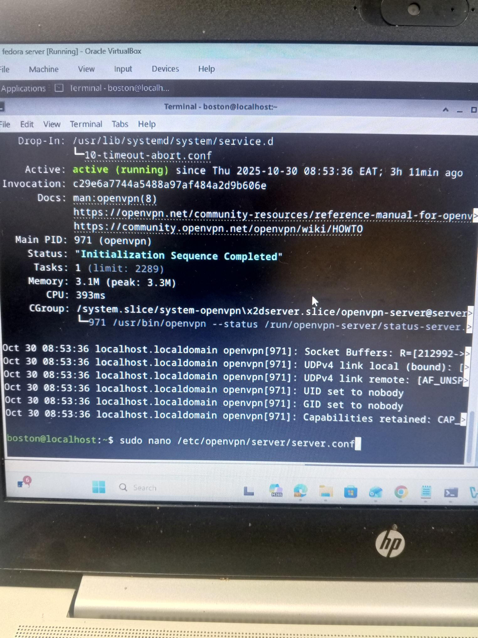

On your fedora browser test ssl https
Test https:/ 10.0.2.15 for me this is my server ip



